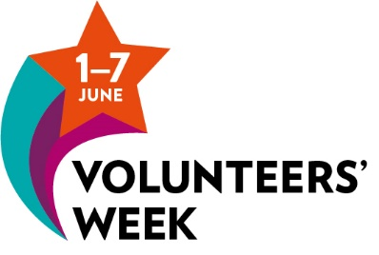
Time to say thank you!
In response to the Covid-19 pandemic 100,000s of people have volunteered to help their local communities joining an army of over 20 million people who volunteer each year to help others. Volunteers’ Week is about thanking our volunteers for giving up their time, energy and skills and recognising the difference they make to our communities.
We know that groups have a lot to deal with right now so we have put together some ideas and resources to help you highlight the difference your volunteers make and ensure your volunteers feel appreciated for all they do. But don’t worry if you aren’t able to join in at this time, recognising volunteers can be done at any time of the year, maybe aligned with a date important to your group.
Ways to say thank you to your volunteers:
- Email a certificate of thanks
- Send a thank you card or ecard ask people who have worked with the volunteer to write a personal message or senior people to write a message of thanks
- Add the volunteers’ week logo to your email signature
- Add the Volunteers’ week campaign banner to your Face book profile
- Add a twitter banner
- Sent them a personalised message during volunteers’ week with something relevant to their volunteering such as a photo or a quote
- Ask beneficiaries or staff to send a photo of themselves giving a thumbs up to be sent to volunteers who have helped them
- Host an online event like a quiz or a coffee social
Get your volunteers to tell other people what they do and why they volunteer
- Ask them to write something on the I Volunteer sheet take a photo that you or they can post on social media with #Ivolunteer and #volunteercambs
- Send them a postcard with space to write what volunteering gives them and ask them to return it so you can create an online montage or post them individually on social media
- Conduct a short interview with some of your volunteers over zoom and record it to share or turn them into short case studies (see end of this document).
Tell the wider community about the difference your volunteers make & tell people how they can be a volunteer
- Create social media posts and use and follow these hashtags to create interest
#volunteercambs #I Volunteer #volunteersweek #clapforVolunteers #CheerForTheVolunteers
- Use Face Book and Twitter but consider other platforms such as Instagram and Pinterest
For example https://www.pinterest.co.uk/markcambridgecvs/volunteer-ads/
https://www.instagram.com/cambridgecvs/
- Tell the local media – send out a press release (see end of this document). Local newspapers and radio are keen to have some good news stories. Local newsletters
Presenting ideas graphically
There are many free versions of tools to make fun and effective graphics, we tend to use Canva. For a great tutorial watch our webinar run by social media consultant Lenka Koppova https://www.youtube.com/watch?v=B78hiUkxjSo&t=9s
Create a thank you image
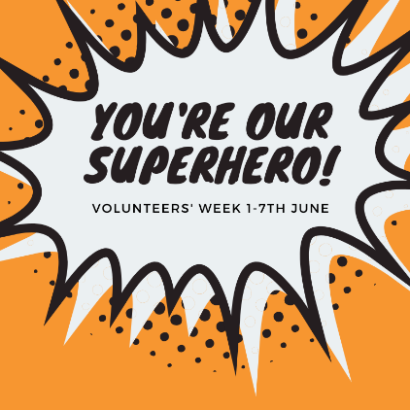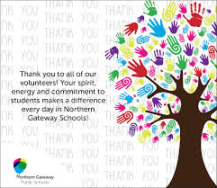
An infographic showing what volunteers have achieved
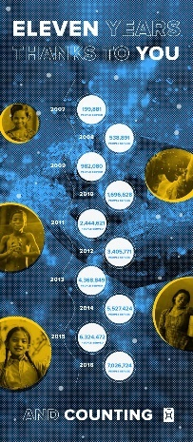
An inspirational quote to post on Face book, Twitter, Pinterest or Instagram

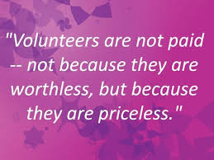

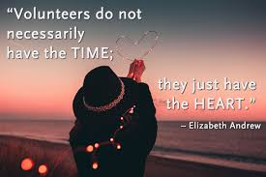

Free photography sources
There are lots of good stock photo images you can use if you don’t’ have your own, just take care they are free to use and you are not breaching copyright. We use Unsplash

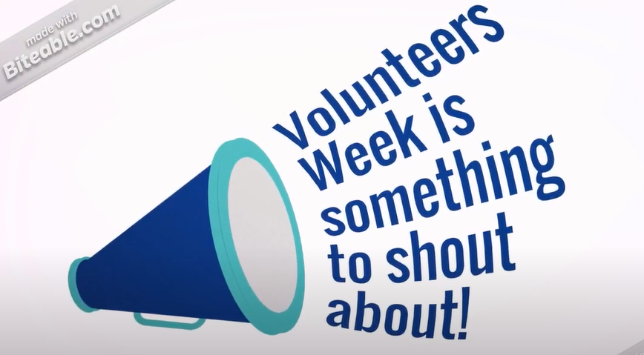
Make a short film, this biteable animation took 20 minutes with no previous experience. https://www.youtube.com/watch?v=XN8R-FUUgq4 with https://biteable.com/

For information here is the original national plan for Volunteers’ Week
Before the Covid-19 crisis there was a national plan put together for Volunteers’ Week but in response to the crisis only the Welsh Council for Voluntary Action (WCVA) is still pushing forward with it. In case your group wants to participate in any of this plan we have included it for your information.
Each day of Volunteers’ Week the WCVA will focus on a different aspect of volunteering to ensure we shine a spotlight on the types of volunteering that have played a significant role in the last twelve months.
Day 1: Volunteers’ Week launch
Join the first day of Volunteers’ Week 2020 on social media. #VolunteersWeek to celebrate the start of the week. Help us trend worldwide again! Please join us for our national #ClapforVolunteers, alongside the #ClapforCarers on Thursday at 8pm.
During the day share messages of thanks from your service users, supporters or patrons. Tell us just how important your volunteers are and share how you are saying thank you.
Day 2: Volunteering in times of crisis
This year, volunteers across the UK have been out in force to support our communities at times of crisis. Thousands of volunteers stepped forward to help others during the severe floods in February and even more signed up and became part of national and local initiatives to meet the needs of people affected by coronavirus. Our national bodies and partners have never been prouder of the kindness and motivation displayed by volunteers.
During the day share case studies of volunteers that have helped during times of crisis. To include volunteers involved in locally led initiatives and those supporting the NHS and health and social care.

Day 3: Youth Volunteering
Today we’ll be placing the spotlight on youth social action. Young people aren't just the leaders of the future, they are leading and making an impact in communities all over the country, today. Let's recognise the #PowerOfYouth!
During the day invite young volunteers to share their stories and takeover your organisations social media. Share messages of thanks for the young people taking a stand in their communities to create positive change.
Day 4: Volunteer Voices
Today we want to hear directly from Volunteers. Using #IVolunteer – let’s tell the world about all the amazing ways you volunteer. We want to hear what difference you are making and what difference volunteering also makes to you.
During the day invite volunteers to share their stories about volunteering from their own perspective and get involved at 8pm as we #ClapforVolunteers (alongside the #ClapforCarers) to show gratitude to all the volunteers that have contributed to their communities over the past year and for those who have helped during the coronavirus crisis.
Day 5: Environment and conservation
To coincide with World Environment Day, we are focusing on all the environmental volunteering that takes place every day. From the smallest to the largest contributions, let us show thanks for the volunteering that makes the planet a better place.
During the day share stories of the volunteering that has supported the environment.
Day 6: Employer supported and skilled volunteers
Do you volunteer though your employer or profession? Are you an employer who supports your staff to volunteer? Do you work with employers or corporate supporters? Then today is the day to get involved and tell us all the great things you have been doing throughout the year
During the day invite those that volunteer through their employer to share the difference volunteering has made to them or encourage employers to use social media to share the ways that volunteering improves their ways of working. Ask skilled volunteers to talk about the ways that their volunteering is making a difference.
Day 7: Review Volunteers’ Week 2020
Let’s look back on Volunteers’ Week (and the many weeks prior to this), recognising the incredible contributions volunteers have made to their communities and say the BIGGEST THANK YOU to every single one of you – let’s keep the appreciation flowing.
During the day share your pictures of how you have shown appreciation to volunteers during the week.

Volunteers’ Week 1-7 June
Press release template

Volunteers at [your organisation] are being thanked for their contribution by [details of how volunteers will be shown gratitude] on [date] to mark Volunteers’ Week, which runs from 1-7 June.
[A brief description of what your organisation does, how many volunteers you have and what they do, and the event.]
Quote from a person at your organisation:
Volunteers are central to the work of countless charities and other organisations. They are a valuable presence in many communities, making a difference in places as diverse as sports clubs, libraries, schools and hospitals.

In 2020, hundreds of thousands of volunteers stepped up to support others in times of crisis. First, as towns and cities across the UK faced severe flooding, emergency volunteers came to the rescue of people trapped in homes and supported the clean-up operation. And, second, volunteers supported those affected by coronavirus, stepping in to deliver essential supplies to those in need and being available at the end of a phone. Charities across the UK will share messages to thank their volunteers and celebrate the power of volunteering to bring communities together and to be there in times of need.

For many volunteer involving organisations the week will also be a chance to inform prospective volunteers of the range of volunteering opportunities on offer.

Notes
To find out more visit (((website)))
Follow #volunteercambs #volunteersweek
For more information please contact: Provide details on who press and media should contact at your organisation

Case Study Template

Interesting headline

Introduction to the volunteer or volunteer team

What need is the volunteer meeting & what difference do they make to others

Quote from a beneficiary, staff member or volunteer

Include a photo

UK Civil Society Almanac 2019 https://data.ncvo.org.uk/volunteering/
Sources https://wcva.cymru/i-work-with-volunteers/ & https://volunteersweek.org/
Adapted from https://wcva.cymru/i-work-with-volunteers/

